**Controller Design**

As a PWM generator and closed loop feedback control, analog controller TL494 is chosen because of its useful properties, which is listed in this part. The design is done using the datasheet of Texas Instruments as a guide. The simplified block diagram and pin layout for this controller can be seen in Figure X-X.

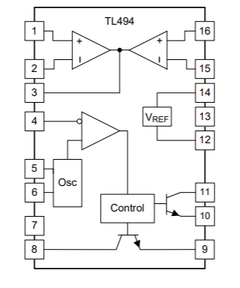

Figure X: Simplified block diagram of TL494

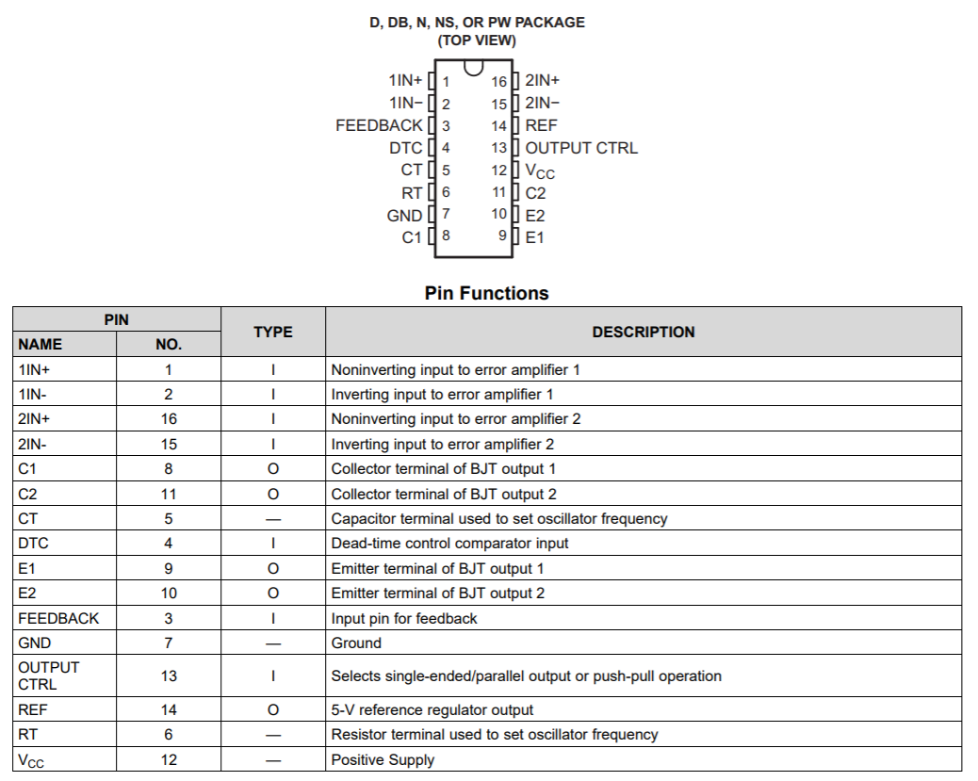

Figure X: Pin layout of TL494 and their functions

1. Oscillator

TL494 allows up to 300kHz oscillation frequency. We have decided to use 20kHz, which will be set with connecting a resistor and capacitor at RT and CT pins. Values of these will be selected using the following formula:

$$f_{osc}=\frac{1}{RT×CT}$$

‬RT=500Ω

CT=100nF

1. Closed loop feedback control

TL494 have 2 error amplifiers. One of them will be used for voltage feedback while the other one can be used for current feedback. Current control will be decided later in the project depending on whether current feedback bonus is aimed or not. Typical design of this part can be seen in Figure X. R7/R5 ratio determines the gain, and higher gain makes the response faster and error smaller. However, it also decreases stability. Therefore, a gain of 10 will be chosen.

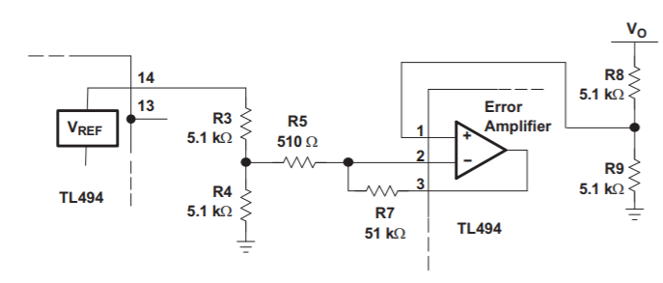

Figure X: Error amplifier of TL494

R3=1kΩ

R4=1kΩ

R5=500Ω

R7=5kΩ

R8= 20kΩ Potentiometer (to get exactly 10 V)

R9=5kΩ

1. Dead Time Control and Soft Start

TL494 allows to set a minimum dead time control, which can be used to limit duty cycle. DTC pin can be adjusted from 0 V to 3.3 V to achieve such limit. This is very helpful for forward converter, since duty cycle should be limited such that there is enough time to reset the transformer. In our case, N1/N3 is 1 and maximum duty cycle of 0.5 is allowed.

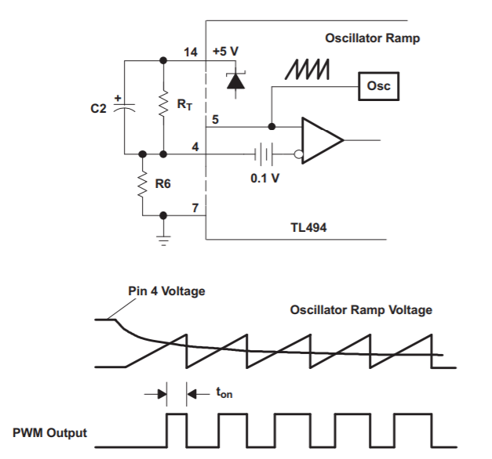

Figure X: Soft start circuit

The controller also allows for a simple soft starting circuit using DTC pin. A typical circuit is given in Figure X. Here, R6 and RT will act as a voltage divider and determine the dead time limit. In our case, they will be selected such that Pin 4 voltage is 1.6 V. From voltage division, R6/(RT+R6) should be equal to 1.6/5 and we have 0.5 duty cycle limit.

$$Ts=C2×R6$$

For a soft starting of 50 clock cycles at 20-kHz, C2=2.5uF will be selected.

RT=2.2kΩ

R6=1kΩ

C2=2.5uF